INFRARED TECHNOLOGY SERVICES
Infrared Inspection Report

Suspect Area Number: | 20
Inspection Date: | 6/27/2010 |  |  | Time: | 2221
Anomaly Location/ Description: | Large irregular area on north side of EF-10  Size is 28 ft. X 15 ft.
View Direction: | Southwest
Anomaly Target Temperature: |  | 92 | Reference Temperature: |  |  | 88

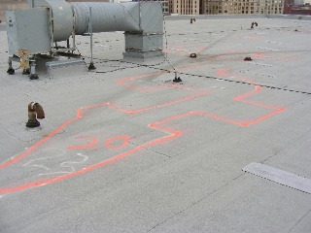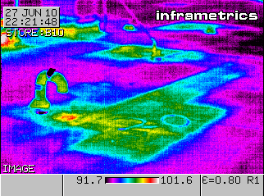

Thermographer: | Lee Wills |  | Sky Conditions: | Partly cloudy
Camera: | Thermacam PM395 |  | Wind Speed: | Moderate
Serial Number: | 20401

