INFRARED TECHNOLOGY SERVICES
Infrared Inspection Report

Anomaly Number: | 9
Severity Rating: | 15 | Inspection Date: | 5/29/2007 | Time: | 1117
Anomaly Location: | Manhole M5, Circuit 3
Description: | Middle phase, hot spot at connector plug

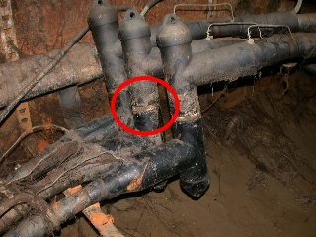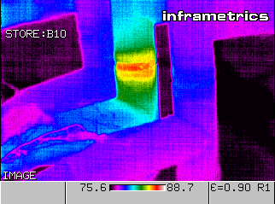

Anomaly Target Temperature: | 86 |  | Rise Above Ambient: | 9
Reference Temperature: | 79 |  | Rise Above Reference: | 7
Ambient Temperature: | 77

Recommendation: | Corrective measures should be taken IMMEDIATELY.

Thermographer: | Lee Wills |  | Emissivity: | .90
Camera: | Thermacam PM395 |  | Distance (feet): | 4
Serial Number: | 20401 |  | Wind Speed: | N/A

Corrective Action Taken | Date | Signature

Return to Letter
Summary of Anomalies

